**Survival analysis of B4GALNT1 in 33 different cancers**

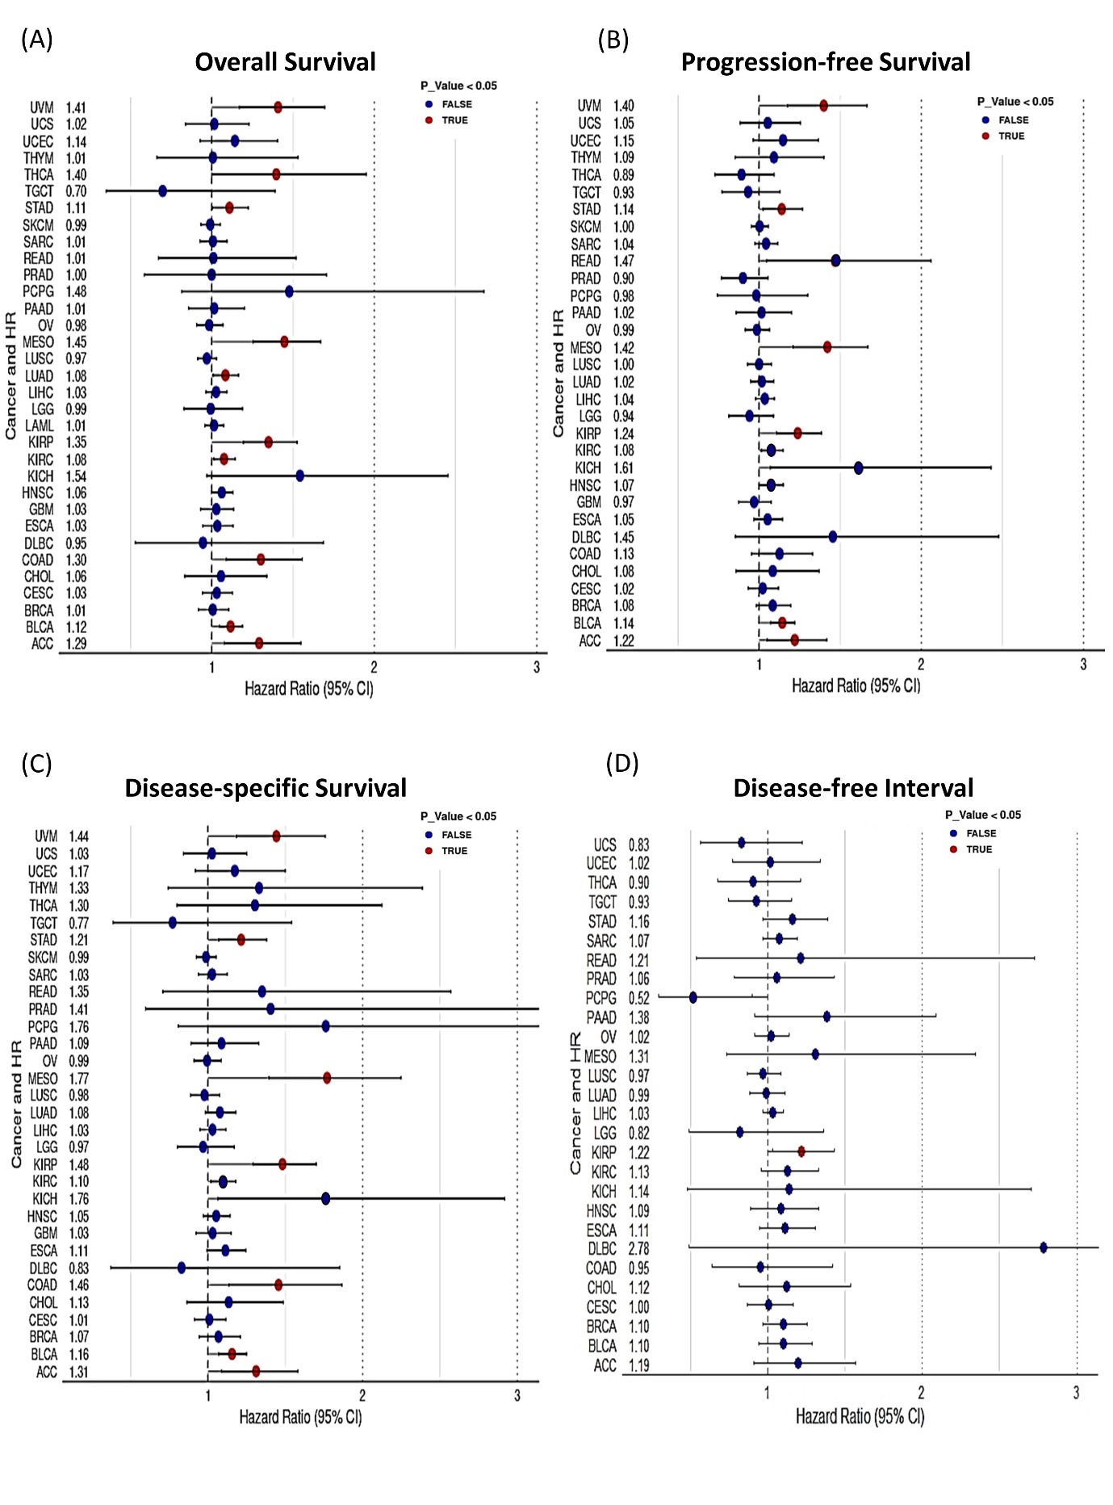

**Figure 1:** Survival analysis of B4GALNT1 in pan-cancer. (A) Overall survival (OS). (B) Progression-free survival (PFS). (C) Disease-specific survival (DSS). (D) Disease-free survival (DFS).

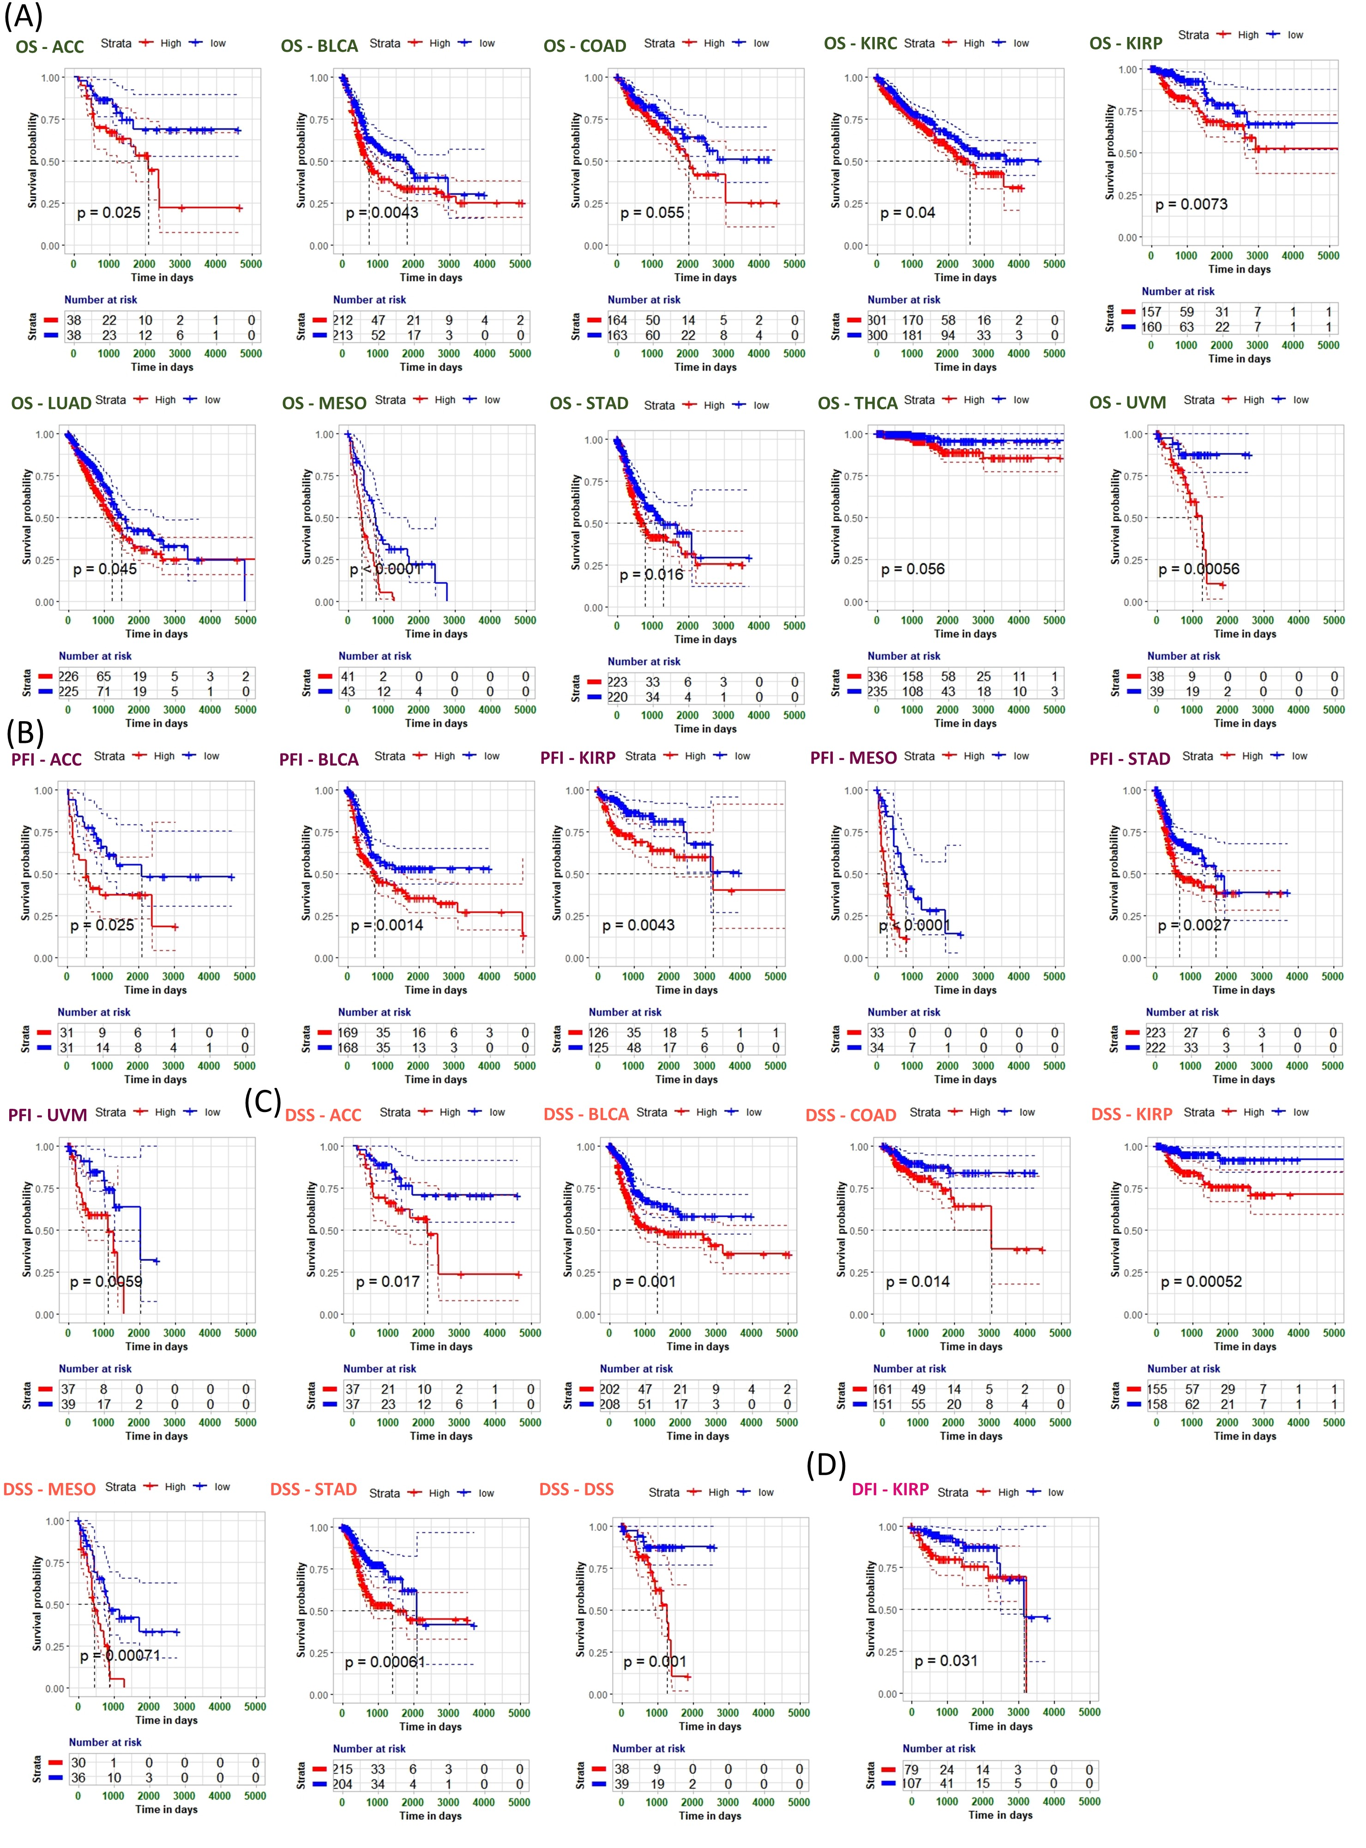

**Figure 2:** Association between B4GALNT1 expression and overall survival (OS), progression-free survival (PFS) (C), disease-specific survival (DSS) (D), and disease-free survival (DFS). Kaplan-Meier analysis of the association between B4GALNT1 expression with the most significant differences in TCGA cancer (p-value < 0.05).